**Mesh Assests with Reflect**

This tutorial helps us to learn how to use the Reflect plug-in to import a Revit project 3D view into a Unity Project.

**Importing**

Step 1

In Revit, Load or create a project and select a 3D view.

Step 2

Select the Unity Reflect tab at the top of the Revit window and click Reflect as in below Figure1.0

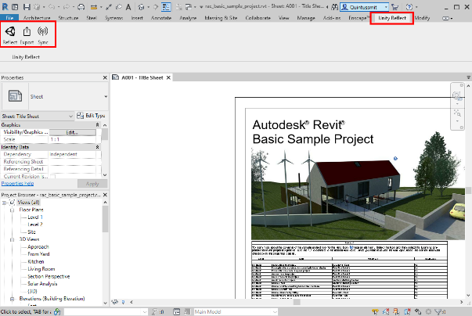

Step 3

Select Export the Unity Reflect window will pop up, allowing you to select or create a project for this view.

Step 4

Click the portrait icon in the upper right and sign in.

Step 5

If you’ve already created a host Unity project, select it in the list Figure1.0 and click Export. Otherwise, Click New Project to Create a new Reflect project Fig1.2 Give your Project a name and select organization it should be linked to

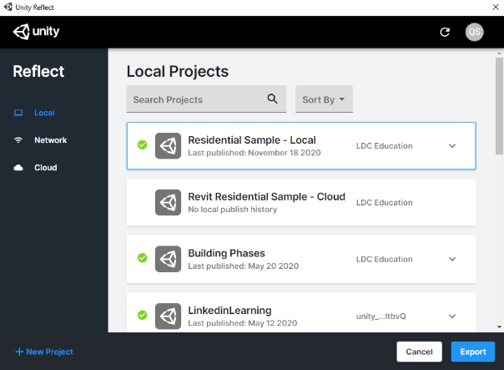

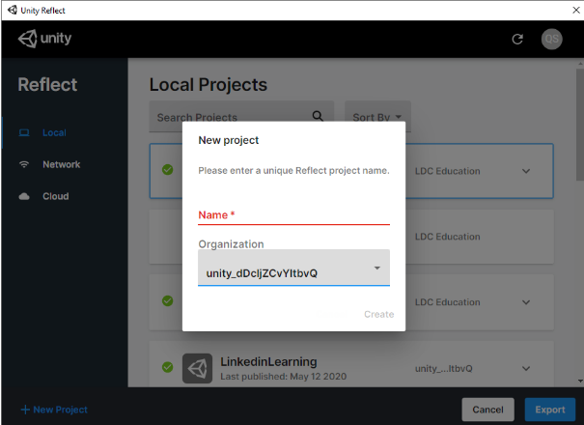

Step 6

In Unity, load the project you selected earlier.

Step 7

If it isn’t already, download and open the Unity Reflect package from Github.

Step 8

Select **Window > Reflect** from the menubar

Step 9

In the Reflect Window, Click **import** under the project name

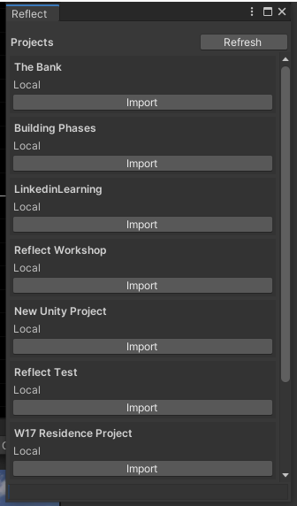

The Revit project is now imported.

**Anatomy of Revit Project**

A Revit project is imported as a single Prefab made up of individual Prefabs for each 3D element. Each individual Prefab is made up of a Mesh and a Material. A Material may optionally use one or more Textures.

The PreFab is located in **Assets > reflect > project name > Revit file name,** with each set of elements in a subfolder of a matching name.

Step1.

In the project view, navigate to **Assets > reflect > project name > Revit file name,** Click to select thePrefab also named for Revit Project file and drag into the Hierarchy panel.

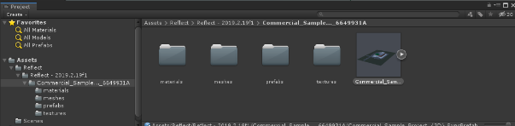 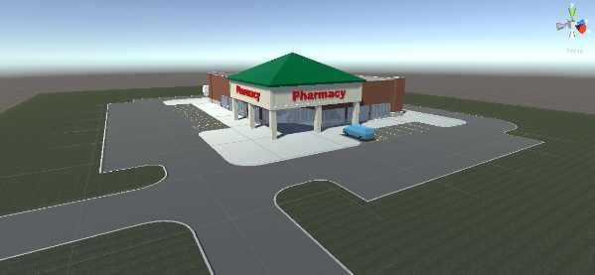

**Changing Materials**

Step1

Select an object whose Materials you wish to change.

Step2

In its Inspector, scroll down to the Mesh Renderer.

The first section lists all the Materials used by the piece in below figure

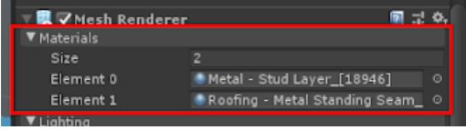

Step3

Click the socket of a Material. In the Select Material window, select a new Material to apply

